Trevor Huis in ‘t Veld

Excel Homework Report – Week 1

Conclusions on Kickstarter Campaigns

The data from the Kickstarter campaign gives numerous insights into the properties of successful and unsuccessful campaigns.

* The most apparent influence on success is the size of the goal. The larger the funding goal, the less likely a campaign is to succeed. Success rates go down while both cancellation and failure rates rise.
* The profile of a large goal campaign (greater than $50,000) and a small goal campaign (less than $1,000) is very different. Theater dominates the small goal campaigns and when a theater campaign attempts a large goal; it’s success rate plummets. Technology dominates the higher ambition projects and boasts higher success rates than the other categories.

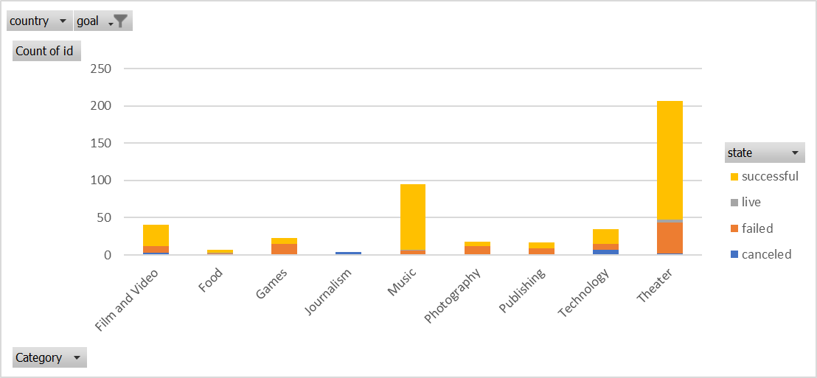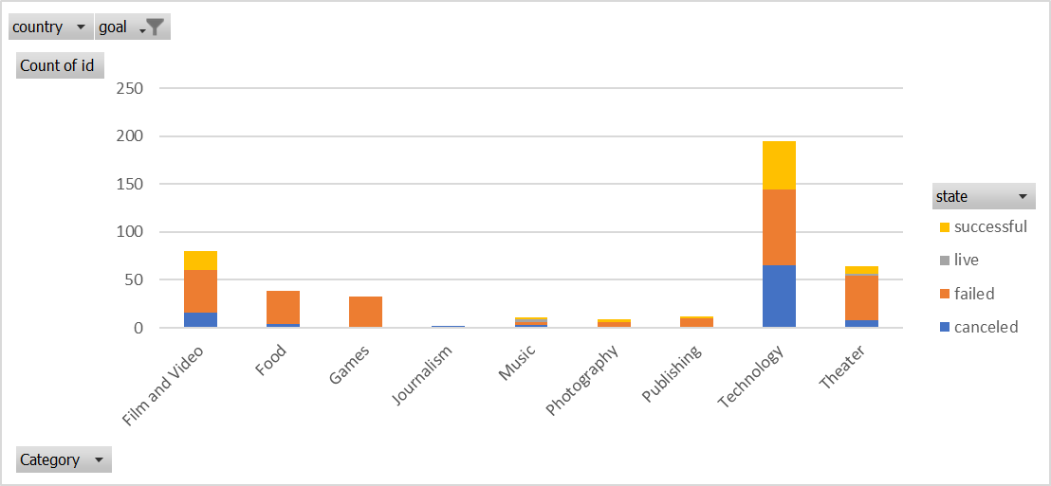

Greater than $50,000

Less than $1,000

* The sub-categories are extremely indicative of campaign success or failure. Out of 41 sub-categories, 32 are either 0% success or 100% success. These subcategories share about the same number of campaigns, so it is not due to a small sample size.



The average and median are measuring number of campaigns.

|  |  |
| --- | --- |
| 100% | 0% |
| Classical Music | Animation |
| Documentary | Art Books |
| Electronic Music | Audio |
| Hardware | Children's Books |
| Metal | Drama |
| Non-Fiction | Faith |
| Pop | Fiction |
| Radio & Podcasts | Gadgets |
| Rock | Jazz |
| Shorts | Mobile Games |
| Tabletop Games | Nature |
| Television | People |
|  | Places |
|  | Restaurants |
|  | Science Fiction |
|  | Translations |
|  | Trucks |
|  | Video Games |
|  | Web |
|  | World Music |

Data Set Limitations

The data provided can only go so far in telling us what aspects lead to a successful campaign. The advertising and description of a campaign could be far more persuasive than another campaign and this data does not account for presentation. There are quite a few “joke” campaigns on Kickstarter that could misrepresent the canceled and failure categories. One example is the $100,000,000 campaign for “The Time Jumper”; $0 were raised.

Other Possible Graphs and Tables

We could analyze how the length of time a project lasted affected its success rate. It’s possible more patient campaigns got their breakthrough in donations late in the process because the more donors a project has, the more legitimacy it appears to have. We could also analyze how the size of donations affected campaigns. Maybe campaigns with grass roots, small support were more successful or maybe successful projects require large donations.